Assignment
Based on the residential tariff of China Light and Power Co Ltd, calculate the electricity bill.
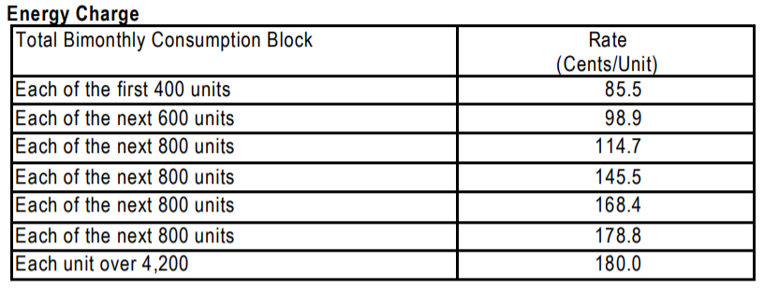
https://www.clp.com.hk/en/Documents/tariff2020/20191210_en.pdf

e.g.
consumption=1000, charge=400x85.5+600x98.9=93540.0
consumption=3000, charge=400x85.5+600x98.9+800x114.7+800x145.5+400x168.4=369060.0
consumption=5000, charge=723460.0

Write your code in Python.
Input consumption from the user.
Output the energy charge.

Add the statement pause=input() at the end of your program.

Additional problem
Solve two simultaneous equations
a1.x + b1.y = c1
a2.x + b2.y = c2
-----------------------------------------------------------------------------------------
e.g.

Enter a1: 2
Enter b1: 3
Enter c1: 31
Enter a2: 12
Enter b2: -7
Enter c2: 11
Solution x= 5.0 y= 7.0

Enter a1: 1
Enter b1: 1
Enter c1: 0
Enter a2: 0
Enter b2: 1
Enter c2: 5
Solution x= -5.0 y= 5.0

Enter a1: 3
Enter b1: 0
Enter c1: 6
Enter a2: 5
Enter b2: 3
Enter c2: 16
Solution x= 2.0 y= 2.0

Enter a1: 4
Enter b1: 7
Enter c1: 19
Enter a2: 8
Enter b2: 14
Enter c2: -3
Parallel lines. No solution.

-----------------------------------------------------------------------------------------

Write your code in Python.
Enter a1, b1, c1, a2, b2, c2
Solve the equations
Output the solution (if any)

Add the statement pause=input() at the end of your program.

