Assignment

Modify the source code of sinewave.py which draws the following canvas.
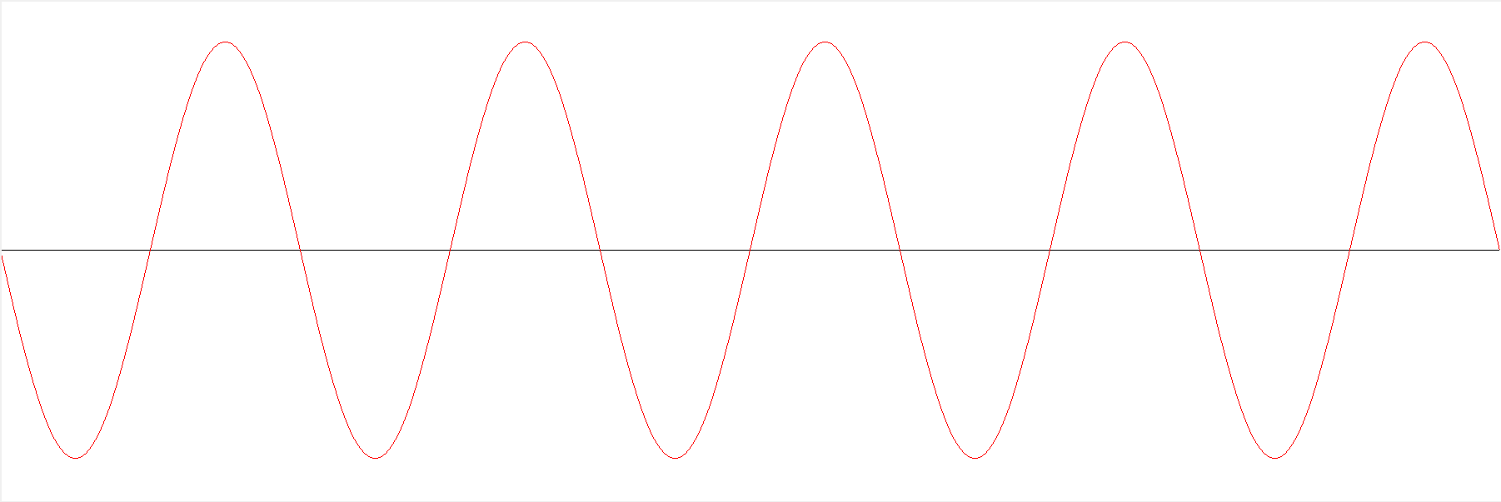

Write your code in Python.

Output the following waves on a canvas.
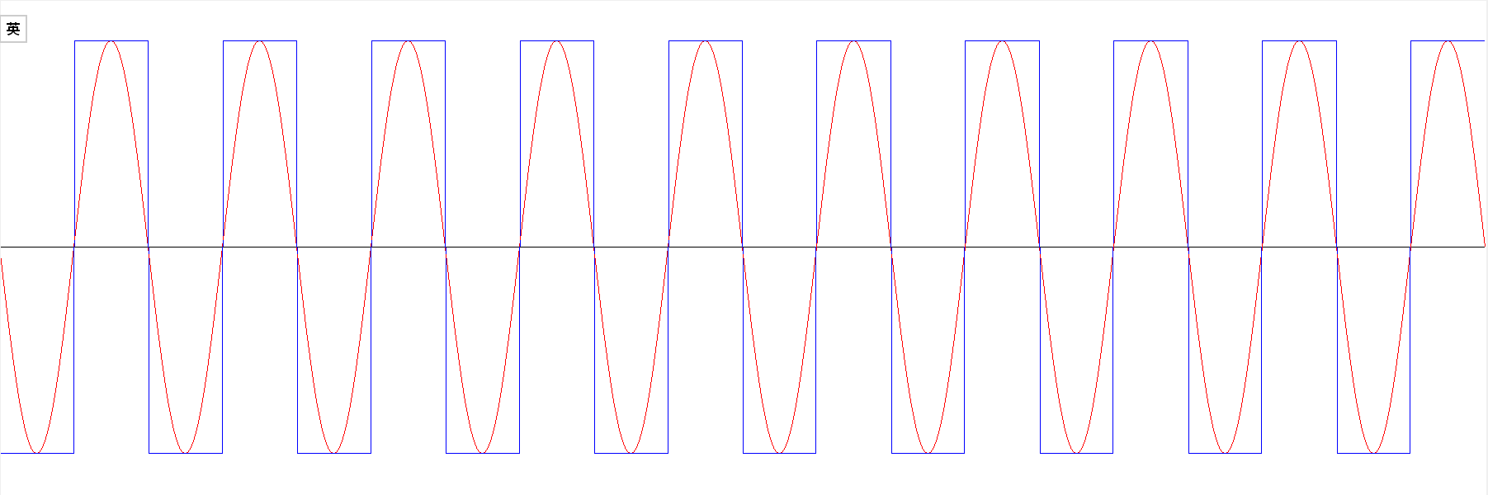

Hints: the blue line is a square wave. It has only two extreme values.

