2017 ICT Paper 2C

2Cq1ai
24 bit true color
RGB -- each 8 bit
#FFFFFF white
#00FF00 green
aspect ratio = 5472:3648 = 3:2

photo paper 8"x10"
paper orientation--landscape (橫,16:9, 4:3, 3:2) and portrait (直,3:4, document, 人像相 etc)
different aspect ratio
1. leave borders (fit-in)
2. crop some parts (fill-in)

2Cq1aii
5472x3648
case 1, use 600 dpi: 8'x10' photo needs 4800x6000 pixels
case 2, use 2400 dpi: 8'x10' photo needs 19200x24000 pixels
The image size is 5472x3648 which fits on using 600dpi.
If 2400dpi is used, the printed image will be very small in size.

2Cq1b
GIF supports only 8 bit colour depth while SWF supports 24 bit true colour.
SWF supports interactivity (script , buttons).
SWF supports audio.
SWF is vector graphic while GIF is BITMAP graphic
SWF animation uses keyframes to make motion tweens.
(keyframe1------------keyframe2-------------keyframe3----------keyframe4)
GIF animation stores frames of bitmap graphics, basic unit of time=1/100s

2Cq1c
toggle a bit, 01, 10
toggle by program
n=-1  x=x*n  x=x*n  x=x*n  x=x*n | x=-x  x=-x  x=-x  x=-x

step 1: Toggle / Invert the colours of the text / Change the color of the text to white / Change the image of the company name to negative.
step 2: Put the image (text) on the top of the camera image.
step 3: Combine them together to form a single image.

How to remove background?
1. use magic wand to select the background. If the tolerance value(similarity value) is set to 30, more pixels/larger area of similar color will be chosen.
2. select the part of the image not selected by the magic wand./Select the unselected parts./Select the objects other than the background.
3. copy the image/objects and paste it on another image/background.

2Cq1di
Different versions of web browsers are used in two computers and they have different default settings. / The font used by the web page is missed in a computer.

2Cq1dii
Use CSS to link to an external font like Google font.
Upload the font to the website and use CSS to link and use the font.
Convert the text to an image. (larger file size, takes longer time to download)
Recommend users to install a particular font. (not practical)

spam / junk email / advertisement
Convert the text to an image and use HTML email to send the image.
The email is not filtered by the email server as spam.

2Cq1e
The contents / compositions of the photos are different.
The compression ratio for a photo with simple shapes and colour combination is smaller.

2Cq1fi
No compression/Lossless compression is applied by RAW, RAW can keep most data of the image.
2Cq1fii
RAW needs special software to view the image, TIFF is most common and has more software supports.

TIFF can contain multiple images. (used by scanner, but PDF is more common now)
TIFF -- store multiple images in a file, suitable for storing scanned multi-pages documents
GIF -- store multiple images in a file, support animation only

2Cq2a
留意kHz單位，留意時間單位
file size = 44100 x 60 x 16 x 2 bit
file size = 44100 x 60 x 16 x 2 / 8 / 1024 / 1024 MB
= 10.093 MB

2Cq2bi
The file has a smaller file size.
Musical notes are editable.
Musical notes can be input directly.
(A MIDI note stores note number, volume, duration of an instrument)

2Cq2bii
He can input musical notes directly using MIDI software.
He can play MIDI piano or other MIDI instruments and record the musical notes.

2Cq2c
reduce the sampling rate (standard CD quality = 44100Hz)
reduce the sample size (common values 24 bit, 16 bit (standard CD), 8 bit)
reduce the number of channels (change from stereo to mono)

2Cq2d
browser -- display scroll bar / menu bar / toolbar / address field / resizable
* pop-up window
Users had to manage multiple windows/tabs on their screens because popup windows would open a separate window/tab on top of the user’s current window.
When a modal window opens, it opens inside the current page. This means that users only need to work within their browser window and don’t have to deal with extra windows popping up.
A lightbox popup is a popup that appears on top of the page's content while the rest of the website is inactivated and dimmed out. As such, they make sure the user focuses on the popup rather than the rest of the screen. Better user experience.

58 days -- use client side script to calculate the number of days
1. get the current date from the client side computer
2. number of days = grad.date - current date

2Cq2ei
Embed the audio HTML code on the page for the upper/lower frame in web page A.

2Cq2eii
Embed the audio HTML code on the page for the lower frame in web page A.
Set the attribute of the audio HTML code loop=true
SWF animation / GIF animation / sound effect / background music / video

2Cq2eiii
Embed the audio HTML codes on the web page after successful login.

2Cq2eiv
Embed the audio HTML code on the page for the upper frame in web page A.
annoying / volume / mute, bandwidth used

*
https://www.w3schools.com/html/html5_audio.asp
In HTML5, there are 3 supported audio formats: MP3, WAV, and OGG.
Plugins are not required.
<audio controls>
<source src="horse.ogg" type="audio/ogg">
<source src="horse.mp3" type="audio/mpeg">
Your browser does not support the audio element.
</audio>

2Cq3
network , update one common database, interactive, real time system
prevent crash of ticket booking

Responsive Web Design
Responsive web design makes your web page look good on all devices (different screen sizes, orientation)
Responsive web design uses only HTML and CSS.

2Cq3a
Find the closest cinemas.
Suggest routes to go to the cinemas.

server-side only : user authentication
validation : client-side + server-side

2Cq3bi
When each of the following tasks is carried out in the website, should a client-side script or server-side script be used?

server-side script. The data of available seats are stored in the database on the server side.
server side -- web pages + database

client-side script. The checking response time is short.
Reduce server work load.

2Cq3ci
* fingerprint is sensitive personal data
best answers: voice/speech recognition, facial recognition
iris scanning, retinal scanning, hand geometry, palm

2Cq3cii
Use a board with 4x4 dots.
Set a minimum number of dots to be connected.
Hide the drawn lines.

2Cq3ciii
(virtual keyboard)
Hackers cannot get the password by obtaining the mouse click positions or hand movement.
Make sure that the user is a real human and not a robot program.

* hide the user name and password by displaying *s.

poor design
zoom in / zoom out, scroll left and right + up and down
poor user experience / poor interface design

2Cq3d
clearly display of thumbnails
user friendly navigation
-- either scroll horizontally or vertically only
description of the use
-- effective layout to arrange the thumbnails and movie information

2Cq3e
* minimum button size

design to show available seats
cross out unavailable seats with X, change its colour
illustrate how to select seat
zoom/scroll/menu

design to show selected seat -- show seat number, change its colour.

* library -- ebook, search, reservation, renew, online payment

2Cq4ai -- navigation menu
Navigation Bar with Dropdown
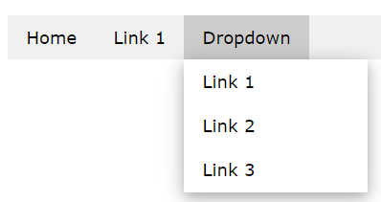 display vertically
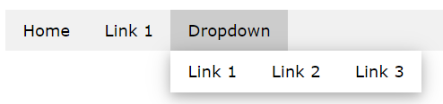display horizontally

Fixed Navigation Bar--To fix the navigation bar to stay at the top or at the bottom of the page, even when the user scrolls the page. The menu is always accessible. (Occupy screen space).

When the navigation bar takes up too much space on a small screen, and you do not want to display it vertically by default, you can use hide and show classes on specific links in the navigation bar.

In the example below, the navigation bar is replaced with a button (☰) in the top right corner when shown on tablets and mobile devices. When the button is clicked, the links in the navigation bar will be vertically displayed.
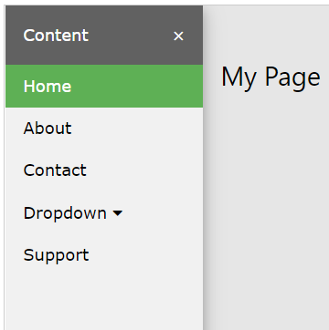
hide show

Tabbed navigation uses navigation buttons (tabs) arranged together with the selected tab highlighted.
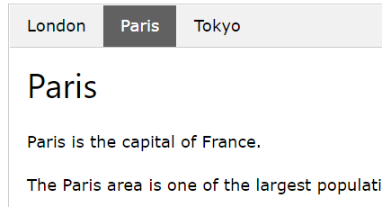
answers: grouping, use of submenu
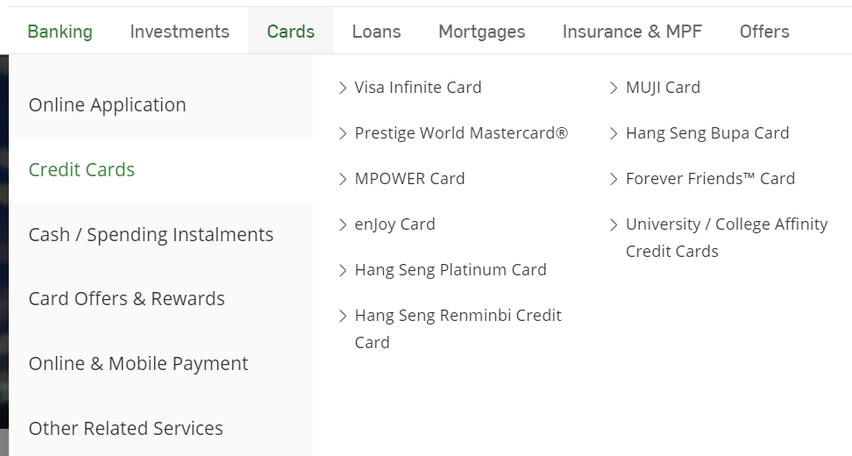

If you have a web site with many pages, you may use pagination. When the pagination link is clicked, the corresponding page will be displayed.
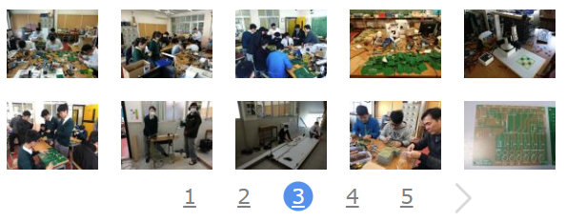 enter the page number _____

2Cq4aii
shorter loading time
accessibility issues, text-to-speech software to convert text to audio for visually impaired people
easier to edit the labels of the buttons
enhance searching by keywords

2Cq4bi
The <head> element is a container for metadata (data about data) and is placed between the <html> tag and the <body> tag. HTML metadata is data about the HTML document. Metadata is not displayed.
Metadata typically define the document title, character set, styles, scripts, and other meta information.
Metadata is data (information) about data. The <meta> tag provides metadata about the HTML document. Metadata will not be displayed on the page. Meta elements are typically used to specify page description, keywords, author of the document, last modified, and other metadata. The metadata can be used by browsers (how to display content or reload page), search engines (keywords), or other web services. HTML5 introduced a method to let web designers take control over the viewport (the user's visible area of a web page).
<head>
<meta charset="UTF-8">
<title>Mi Teen </title>
<meta name="description" content="Free Web tutorials">
<meta name="keywords" content="HTML,CSS,XML,JavaScript">
<meta name="author" content="John Doe">
<meta name="viewport" content="width=device-width, initial-scale=1.0">
</head>

The <title> element:
defines a title in the browser tab
provides a title for the page when it is added to favorites
displays a title for the page in search engine results

answers:
keywords of the web page are added to a meta tag to increase the chance of being searched by search engines.
character coding is added to a meta tag to indicate the coding scheme used.
description of the web page, title, author, coyright, creation date, last modification date

2Cq4bii
cookies -- no virus / browsing activities are recorded -- clear cookies
要針對處境clinic
Record the last page visited by the client and display the page for the next visit.
Record the duration of browsing different pages and display relevant information for the client.
Record the banner ads that were shown in the past so that other new banner ads can be shown for the next visit. (但個sample無banner ads)

2Cq4c
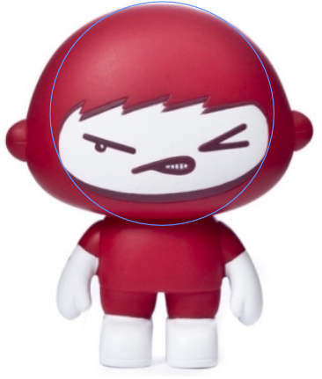
Image map
For a normal image link, the entire area of the image links to a single destination. 1 image 1 hyperlink
An image map is a list of coordinates relating to a specific image, created in order to hyperlink areas of the image to various destinations.
The intention of an image map is to provide an easy way of linking various parts of an image without dividing the image into separate image files. You can create multiple hotspot areas, but they are part of the same image map.

answers
For each part of the tooth, create an area or a polygon (hotspot) on the image and assign the corresponding hyperlink to that area.

2Cq4di
The aspect ratios of the video and the screen are different.
fit-in -- show the entire video but leaves borders (L/R or U/B)
fill-in -- the video fills the entire screen, but some parts are cropped
stretch the video to fill the screen, aspect ratio is changed

2Cq4dii
uncompressed video only
duration x 25 x 1280 x 720 x 24 bit = 20 x 2³⁰ x 8 bit
= 310.689s

2Cq4e
check the correctness of the questions (if)
accumulate the number of 'true'
loop for 10 times
display the health condition according to the number of 'true'
n=0
for i=1 to 10 do
input the answer
if answer=true
n=n+1
if n>=7 print "healthy"
else if n>=4 print "need improvement"
else print "unhealthy"

