Task010
Design a wedding invitation card

File name: index.htm
Web page title: Wedding invitation card
Upload your webpage to the folder <task010>

Useful links:

Basic HTML structure
https://www.w3schools.com/html/default.asp

HTML Paragraphs
https://www.w3schools.com/html/html_paragraphs.asp

Text alignment
<p>demonstration</p>
<p style="text-align: left;">demonstration</p>
<p style="text-align: center;">demonstration</p>
<p style="text-align: right;">demonstration</p>

Style to set center alignment and the width of the body
width:800px;margin:auto;

Font size
<p style="font-size: 2.5em;">demonstration</p>

HTML Entities
https://www.w3schools.com/html/html_entities.asp

Google fonts
https://fonts.google.com/
Use the handwriting font Pacifico
Traditional Chinese fonts: Noto Sans TC, Noto Serif TC

------------------------------------------------------------------------------------------------------------------------------------
Sample
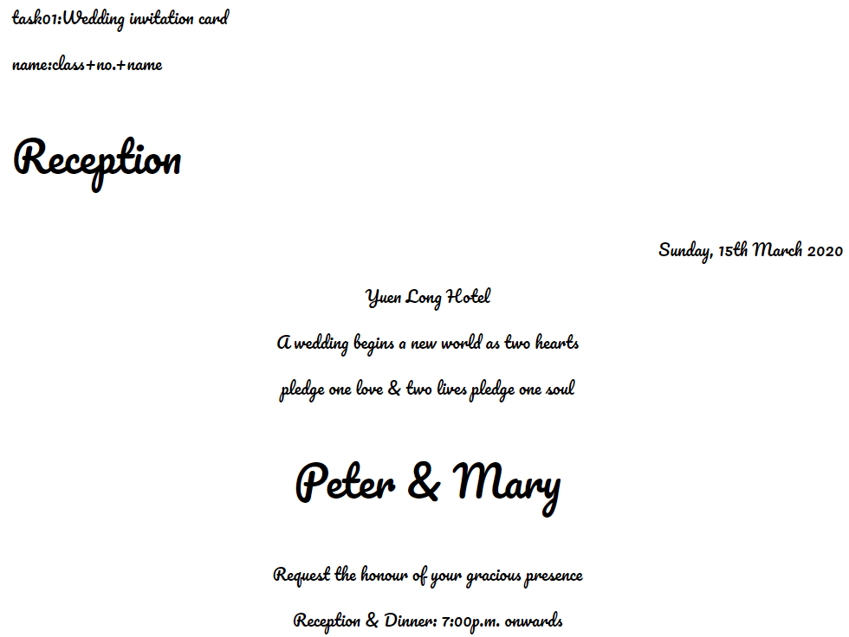
------------------------------------------------------------------------------------------------------------------------------------
Text

Wedding invitation card

task01:Wedding invitation card
name:class+no.+name

Reception
Sunday, 15th March 2020
Yuen Long Hotel
A wedding begins a new world as two hearts
pledge one love & two lives pledge one soul

Peter & Mary
Request the honour of your gracious presence
Reception & Dinner: 7:00p.m. onwards
------------------------------------------------------------------------------------------------------------------------------------
Hints

<!DOCTYPE html>
<html>

<head>
<title>Wedding invitation card</title>
<meta charset="UTF-8">
</head>

<body>
<p>task010: Wedding invitation card</p>
<p>name: class+no.+name</p>
<p>Reception</p>
<p>Sunday, 15th March 2020</p>
</body>

</html>

